2022-2023
4-H Recordbook
TIP SHEET

This booklet is designed to help GUIDE you through the recordbook process. Please also use the family guide to refer to specific details regarding recordbook guidelines.

TIPS WHEN COMPLETING RECORDBOOK!!!
1. Before creating book: Take pictures throughout the year
2. Before creating book: Write everything down in your calendar
3. Before creating book: Look at other books to get an idea of what to do in your book!
4. Before creating book: Determine main project and other projects for book!
5. Put all 4 years in recordbook form (no past year’s books in the back)!
6. Use WORD document downloads instead of doing it online!
7. Some state forms do not include tables. There are some examples within the booklet of suggested table formats. Note: these are not mandatory but a helpful guide on how to do the blank pages on the form.
8. Dividers are allowed to separate forms for each year!
9.Green recordbook covers are available after you complete your recordbook. You can contact your County Extension Office.

Please read the Family Guide Instruction book provided by the state so you know any new changes and other guidelines!

Recordbooks should be compiled in this order:
- Check Sheet
- Personal Information Page
- 4-H Story and Photo Portfolio
  - Make sure look at min and max pages for each age
- Report Forms
  - Make sure look at min and max pages for each age
- PLEASE SEE NEXT PAGE FOR SPECIFICS

If you have any questions, please do not hesitate to ask!

To Download forms and other guidelines: https://texas4-h.tamu.edu/recordbooks/

Milam County 4-H Recordbook Website and Forms:
https://milam.4h.agrilife.org/4-h-activities/recordbooks/

Compiled by:
Micah Holcombe, County Extension Agent – Family & Community Health, Milam County
Laura Huebinger, Extension Program Specialist – 4-H Youth Development, Volunteerism

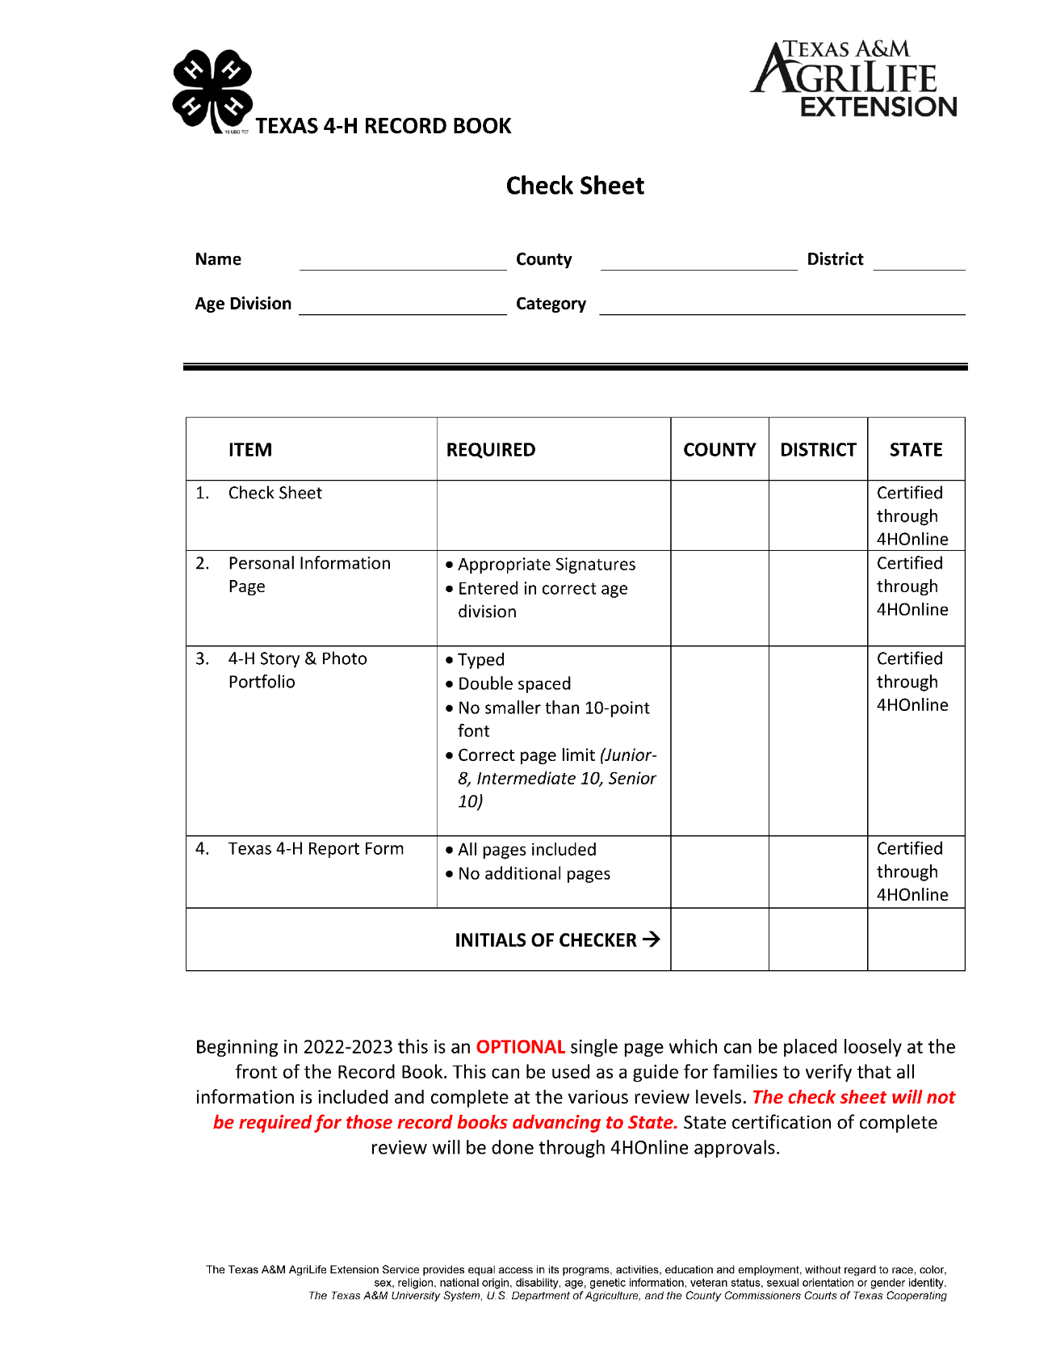

Personal Information Page
2022-2023

Name |  |  |  |  |  | County |  |  |  |  |  | District
Age Division |  |  |  |  |  | Category
Number of years in 4-H |  |  |  |  |  | Number of years in Main Project
(excluding Clover Kid years)
Address |  |  |  |  |  | Home Phone
City, State, Zip |  |  |  |  |  | Mobile Phone
Best Email
Date of Birth |  |  |  |  |  | School Grade
Place of Residence
 |  | Farm/Ranch
 |  | Rural area or Town less than 10,000
 |  | Town or City of 10,000 to 50,000
 |  | Suburb or City of more than 50,000
 |  | Central city of more than 50,000
Name of your 4-H Club or Group |  |  |  |  |  |  | Check with Extension Office for # of members in each club
Number of members in your 4-H Club or Group
4-H Member Signature |  |  |  |  |  |  |  |  |  | Date
Parent Signature |  |  |  |  |  |  |  |  |  | Date

4-H Story & Photo Portfolio

The story should focus on information from the current year; however, it may also include information from prior years.
Look at the TABLE on page 3 for minimum and maximum pages!

Title the portfolio as follows: “My 4-H ___________ (Record Book Category) Story and Photo Portfolio.” For example, “My 4-H Horse Story and Photo Portfolio.” A subtitle may be added.

The story should include information in ORDER:
• Information about yourself, your family, and your community
• When and why you joined 4-H
• Project Goals (Starting with your main project)
• How 4-H has helped you become a better leader and citizen and what you have learned through your community service and leadership activities
• How being a 4-H member has helped you set goals (include the goals) and develop new interests, and if 4-H has influenced your future plans or career goals

The photos used are very important and should reflect growth, development and involvement in the member’s 4-H career. Use photos that show the member doing things, learning and teaching others, and especially having FUN in 4-H. Use photos that show the main project, other projects, leadership, and community service.

Photos depicting family activities, livestock auctions, U.I.L., sports events, other school events (non-4-H related photos) are not to be included. This is your 4-H Record Book.

Captions help tell the story and describe what is in the photo but are not required. Story and photos may be combined. Color and/or black and white photos, clear sharp copies of photos (scanned and/or color copied), and newspaper photo clippings may be included. Newspaper articles are not allowed.
• The combined portfolio should be completed within the page limits listed in the Texas 4-H Record Book Summary (page 5) for each age division.
• Text is to be double-spaced type, using a minimum of a 10-point or equivalent size font.
• Photos may be placed throughout the story, adhering to the minimum number of equivalent pages as listed on page 5 or they can be all grouped together.
• Effective September 1, 2018 - Record Books submitted in the Photography category follow the same guidelines regarding number of photos included. DO NOT include extra photos.

2022-2023
Texas 4-H Record Book Report Form
SECTION I – 4-H PROJECT EXPERIENCES
4-H Project Summary and Learning Experiences – What is your project? How did your project change or grow? What have you done and what have you learned? You can include learning experiences gained in other youth/community organizations but applicable to the 4-H project. Individually-directed project learning experiences are also acceptable. Include up to 4 projects, current year and up to three preceding 4-H years (up to two preceding years for Juniors). Maximum page limits: Junior - 2 pages; Intermediate – 3 pages; Senior – 4 pages.
This is includes 4 projects for the current year!
Must include in this section:
• Level of Participation
o (Local, Club, District, State, National, International)
Look at the TABLE on page 3 for minimum and maximum pages!

• Make sure you elaborate on the importance of these events.
• Remember….who cares? Let us know why it matters!!!!

AN EXAMPLE OF A TABLE THAT CAN BE USED (NOT REQUIRED):

Project 1: (How many years in project)
Description | Year | How many? | Level  (L,C,D, S, N, I)

What have you learned? | Year | Hours Spent | Level  (L,C,D, S, N, I)
Explanation of what to put in the table above:  (General to all projects):  • Trainings/Workshops  • Classes  • Tours  • Demonstrations/Educational Presentations  • Leadership  • Taught/Served  • Competitions Entered  • Tours-Places Visited  Description  • Demonstrations/Educational Presentations  • Project Meetings  • Hours Spent  • People Reached  • Research Hours Spent or Group/Independent Study  Hours  • Awards | What have you learned:  Learning Experiences  • Knowledge Gained  • Research  • This can also be other “soft”  skills like responsibility,  decision making, selfconfidence,  work ethic, critical  thinking, etc.
EXAMPLES SPECIFIC TO SOME COMMON PROJECTS
Public Speaking/Leadership:  Make sure you emphasize Learning in these projects! Not just holding an office!  • Presentations/Reports given at meetings  • Offices Held  • Presentations to Non-Profit Organizations  • Presentations to Non-4-H  • Pledges Led,  • Workshops Led  • Group Leader  • Master/Mistress of Ceremonies or Script  • 4-H Promotional Presentations  • News Articles written  • Committees/Boards Served  • Served in leadership role at an event  Animals:  • Animals Purchased  • Animal Feed/Medicine-Vet Expenses  • Sale Income  • Profit/Loss  • Number Sold  • Shows Entered  • Equipment Expenses  Horse:  • Horses Trained  • Younger members who have been trained by you  • Horses bought/sold  • Look at Animals  Fashion and Interior Design:  • Garments/Textiles Sewn  • Dollars Saved by sewing  • Patterns Bought  • Material Bought- (yards)  • Prize Money Earned from County Fair  • Items Designed and completed | Food and Nutrition:  • Meals/Dishes Prepared  • Tables Set  • Money Saved by cooking at home  • Coupons used/saved  • Prize Money Earned from County Fair  • Scenarios Written  • Reasons Given  • Hours Spent Studying  Consumer:  • Budgets Made  • Classes Created  • Hours studying  • Kahoot It! Quizzes Completed  • Reasons Given  Photography:  • Picture Development Expense  • Pictures Taken  • Photos entered  • Prize Money Earned from County Fair  Shooting Sports:  • Guns Bought  • Practice Meets  • Ammo Purchased-$  Recreation:  • Games lead  • Recreation Planned  • Icebreakers Led  • Workshop recreation given/lead  Gardening/Horticulture:  • Gardens planted  • Plants planted  • Plants Bought # and $  • Gardening Equipment and other Expenses | Veterinary:  • Animals Treated  • Vaccinations Completed  • Animals Cleaned  • Hours at Vet Volunteering  Plants and Animals Open:  • Animals Vaccinated  • Animals Groomed  • Hours at Vet Volunteering  • Pets Adopted  • Pets sold  • Hours spent cleaning animal’s homes  Range Management/Plant & Soil Science:  • Soils/Plants Gathered  • Plants Studied  • # Soils Tests  Conservation and Natural Resources/Aquatic  Science:  • Fish Caught  • Fish cleaned and ate/cooked  • Hatcheries visited  • Boats Repaired  • Lifeguard Training  • # of times gone fishing  • Camps attended- Water Cam  Theater and Performing Arts:  • Plays  • Λινεσ λεαρνεδ  • Αχτσ χομπλετεδ  • Performances  • Camps  Health and Personal Safety:  • Healthy presentations given  • Ηεαλτηψ Λιφεστψλεσ Πραχτιχεσ/Χοντεστσ  • Ηεαλτηψ Λιφεστψλεσ Αμβασσαδορ  • Τουρσ  • Camps

2022-2023
Texas 4-H Record Book Report Form
SECTION II – 4-H LEADERSHIP EXPERIENCES
List what you did to assist others throughout this 4-H year. Also include general leadership such as Club Officer, 4-H County Council, or County Committees. Include elected/appointed, volunteer, and promotion leadership. Leadership Role: E-elected, A-appointed, V-volunteer, P-promotional. Level: Cl-club, Co-county, D-district, S-state, N-national, I-international. Include current year and up to 3 preceding 4-H years of activities (up to 2 preceding 4-H years for Juniors). Entry and page limits: Junior – 10 entries and 1 page; Intermediate – 15 entries and 2 pages; Senior – 25 entries and 3 pages.
 | Year | Leadership Activity | Role  (E, A, V, P) | Level (Cl, Co, D, S, N, I) | Responsibilities / Duties / Accomplishments  Look at the TABLE on page 3 for minimum and maximum pages!
1
2
3
4
5
Section II should not include Any leadership opportunities that occurred while performing community service. Providing primary leadership to a community service effort should be reported in Section III.
Promotion Leadership: How  have you told someone about 4-H?  • Newspaper Articles  • Wear 4-H Shirt  • School Announcements  • National Volunteer Week  • Commissioners Court  • Told a friend about 4-H  • Got a friend to join 4-H  • Taught a friend something  you learned about in 4-H  • Booth at Open House/Meet the Teacher Night  • Picture in National 4-H  Calendar  • Exhibit at Mall of 4-H  Photography  • Sold 4-H raffle tickets | Volunteer Leadership: How and what did you do to lead or teach others in 4-H?  • FUNDRAISERS GO HERE!  • Lead officer installation at  4-H Club  • Helped setup and clean  up at 4-H events  • Helped 4-H members with  4-H projects  • Script part at 4-H contests  • Taught a friend something  you learned about in 4-H  • Group leader for Safety  Day/Ag Days  • Helped with Photo Exhibit  at Mall and Library  • Helped make judges gifts  • Helped conduct session at  project workshop  • Handed out programs at  county or district contest | Elected Appointed: What did  you do to improve 4-H?  • (Add how many in club,  what do you do in the  office-duties)- Include  number of club members  in roles and  responsibilities!!!!  • Club, County, District,  State Officer Positions  • Led Pledges at meeting  • Gave report at meeting  • Committees  • Brought refreshments at  meeting  • Took pictures for event

2022-2023
Texas 4-H Record Book Report Form
SECTION III – 4-H COMMUNITY SERVICE
List community service or service learning projects that might include: clean ups, collections, repairs, construction, care packets, visitations, education, donations, presentations, etc. Your Role: Y-Yourself, M-Member of a Group, P-Primary Leadership. Include current year and up to 3 preceding 4-H years of activities (up to 2 years preceding 4-H years for Juniors). Entry and page limits: Junior – 10 entries and 1 page; Intermediate – 15 entries and 2 pages; Senior – 25 entries and 3 pages.
 | Year | Your Role  (Y, M, or P) | Service Activity | Importance and Impact  Look at the TABLE on page 3 for minimum and maximum pages!
1
2
3
4
5
What did you do to help other people because of 4-H?
NO FUNDRAISERS IN THIS SECTION!!!!! Must be service that does not have a fundraiser for your club or to benefit you in any way. Now if you did a benefit for someone and raise money to help them it could be service. Just not to benefit you somehow.

Y: Completed Community  Service by yourself  • Donated clothes to good  will, etc.  • Made a dish for potluck at  church  • Donated coke tabs to  Ronald McDonald House  by yourself  • Helped elderly with  something at house---  without taking money!!! | M: Completed Community  Service with a member of a  group- club, county council  • Anything your club or  county council does as a  group community service  project.  • Gathering supplies for  disaster relief  • Coat Drive for County  Council  • Dry Milk for Helping  Hands  • Coke tabs to Ronald  McDonald House  • Highway Clean up | P: Lead and implemented  community service project  • Led Blankets of Love  project for club and  coordinated with club  manager on how to get the  project going and finished.  • (SENIORS!!!!- YOU NEED AT  LEAST 1-3 P’s in your  book!!!)  • ALL P’s need to have one of  these words to show you  actually had leadership.  • Coordinated  • Led  • Organized  • Planned  • Created  NOTE: You can be part of an officer team who leads the project and still count it as a P
2022-2023
Texas 4-H Record Book Report Form
SECTION IV – OTHER 4-H PROJECTS
List any 4-H project(s) not listed in Section I, include number of years and summarize participation. Include current year and up to 3 preceding 4-H years of activities (up to 2 preceding 4-H years for Juniors). and any number of projects. Limit to 1 page (Juniors) Limit to 2 pages (Intermediates & Senior).

List any 4-H Projects not listed in Section I. Include number of years and summarize participation.
Remember you can add projects you just dabbled in. For instance, you went to a workshop on a project during the summer, you can make that a project as long as you have 6 learning experiences. Remember leadership, public speaking, and citizenship and civic education (community service) are projects and can be added to this section. You generally have this project throughout your other projects.
Make sure that you use Projects on the Project List!
• This page could be just one project or several projects.
• Can be in paragraph form (not optimal)
• Include project name
• Divide years within project
Tip: Use the Section I Project lists and ideas for this section as well.

AN EXAMPLE OF A TABLE THAT CAN BE USED (NOT REQUIRED):
Project 5: (How many years in project)
Description |  | Year |  | How many? |  | Level  (L,C,D, S, N, I)
What have you learned? | Year |  | Hours Spent |  | Level  (L,C,D, S, N, I)
 |  |  | Look at the TABLE on page 3 for minimum and maximum pages!

2022-2023
Texas 4-H Record Book Report Form
SECTION V – 4-H RECOGNITION AND AWARDS
List 4-H recognition and awards. Level Cl-Club, Co-County, D-District, S-State, N-National, I-International. Include current year and up to 3 preceding 4-H years of activities (up to 2 preceding years for Juniors). Entry and page limits: Junior – 10 entries and 1 page; Intermediate – 15 entries and 2 pages; Senior – 25 entries and 3 pages.
 | Year | Level (Cl, Co, D, S, N, I) | Recognition | Importance to You  Look at the TABLE on page 3 for minimum and maximum pages!
1
2
3
4
5
6
7
8
9
10

Highlight 4-H Recognition and/or Awards
Section Must Include:
• Activity Date
• Level of Award
• Award
• Importance to You

Include:
• County and Club Awards
• District Awards
• County Youth Fair Awards- only high ones
• Placing at contests- only high ones
• This does not include FFA livestock shows
• Show how it is important (1st out of 45 entries)

2022-2023
Texas 4-H Record Book Report Form
SECTION VI – NON-4-H ACTIVITIES
List leadership, community service, awards, and recognition from other activities such as school, church, and other community organizations. Include current year and up to 3 preceding 4-H years of activities (up to 2 preceding years for Juniors). Limit to 1 page.

Leadership, community service, awards, and recognition from other activities such as school, church,
and other community organizations.
Leadership Examples:  • County Youth Board  • VBS teacher  • Chamber of Commerce  • Captain of Sports Team  • TAFE  • FFA Officer  • Read Scriptures at  church  • Help with Technical  stuff at church  • Student Council | Community Service Examples:  • Volunteer at Vet  • Volunteer at Good Will,  Food Pantry, etc.  • Can Food Drives  • Donated clothes to  good will, etc.  • Helped neighbors  • Mow yards for no cost  • Volunteer at Youth  Center | Awards/Recognition Examples:  • FFA Shows  • Honor Roll  • UIL  • Athletics  • TAKS Award  Look at the TABLE on page 3 for minimum and maximum pages!

Leadership Type | Year | Responsibilities / Duties / Accomplishments | People Reached/Hours Spent | Level  (L,C,D, S, N, I)

Community Service Type | Year | People Reached/Hours Spent | Level  (L,C,D, S, N, I)

Award Type | Year | Placing | Level  (L,C,D, S, N, I)

2022-2023
Texas 4-H Record Book Report Form
SECTION VII – COLLEGE & CAREER EXPLORATION
Please answer the following question before completing the required portion of the table.
As of today, what career would you choose?
List activities that have helped you learn more about careers or the necessary education to enter a career. Examples of activities include: interviews, tours, job shadowing, research, mentoring, work experience, skill development, course work, etc. Include current year and up to 3 preceding 4-H years of activities (up to 2 preceding years for Juniors). Entry and page limits: Junior – 10 entries and 1 page; Intermediate – 15 entries and 1 page; Senior – 15 entries and 2 pages.
 | Year | Activity Title | What did you learn or do?  Look at the TABLE on page 3 for minimum and maximum pages!
1
2
3
4
5
6

4-H and NON 4-H activities that have helped member learn more about careers or the necessary
education to enter a career of interest.

Section Must Include:
• Activity Date
• Activity Title
• What did you learn or do?
• Hours

Items that could go here:
• Tour of College
• Research of Career
• Research of Colleges
• Scholarship Interviews
• Interviews you have given to people in your career to be pursued
• Job Shadowing
• Work experience- more to your career
• Even include opportunities that somewhat relate to your career- Ex. You would like to be a
chef….you might attend the Taste of Home Cooking School or attend a Cooking Demonstration
• Course Work

